# Apply filters to SQL queries

## Project description

In this scenario, I will apply different queries to the ‘log_in_attempts’ and ‘employees’ databases to investigate potential security issues. As a security analyst, part of my job is to investigate security issues to help keep the system secure.

## Retrieve after hours failed login attempts

The query selects all columns from the ‘log_in_attempts’ table and shows only the rows that have a login time after 18:00 AND the attempt is failed, both conditions having to be met.

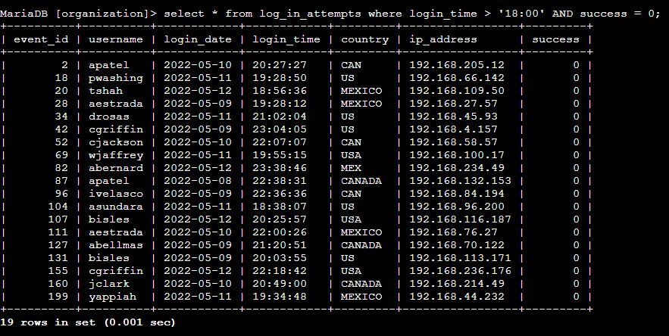

## Retrieve login attempts on specific dates

The query selects all columns from the ‘log_in_attempts’ table and shows the rows that have a login date between 2022-05-08 and 2022-05-09, of course including the two ends of the condition.

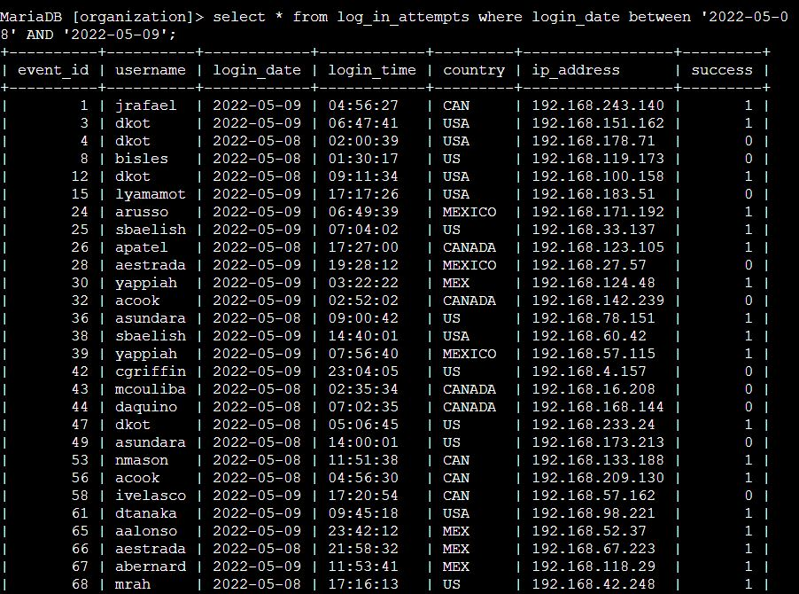

## Retrieve login attempts outside of Mexico

The query selects all columns from the ‘employees’ table. The syntax ‘where not’ negates the condition after it, so the query has to show every row apart from the ones where the country column begins with ‘MEX’. 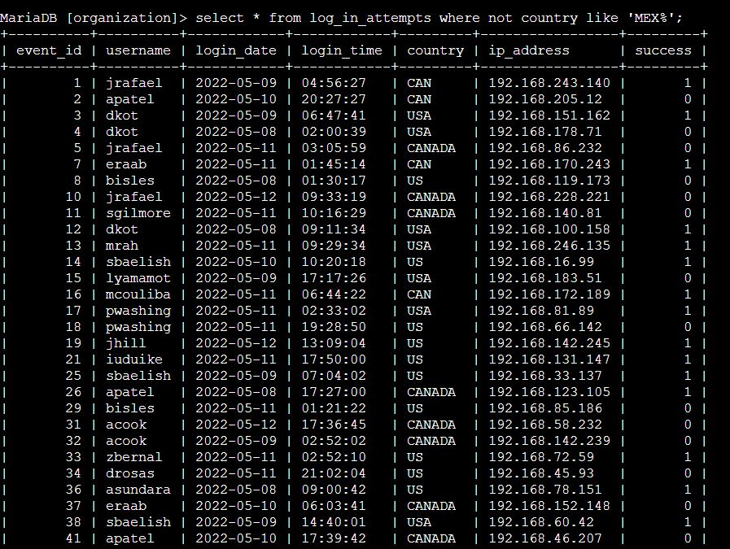

## Retrieve employees in Marketing

The query selects all columns from the ‘employees’ table and shows only the rows with the department ‘Marketing’ and the office name beginning with ‘East’, both conditions having to be met.

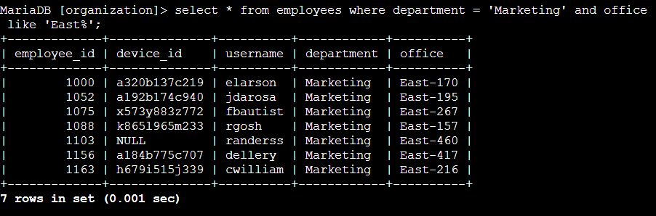

## Retrieve employees in Finance or Sales

The query selects all columns from the ‘employees’ table and shows only the rows with the department ‘Finance’ or ’Sales’. Either condition can be met.

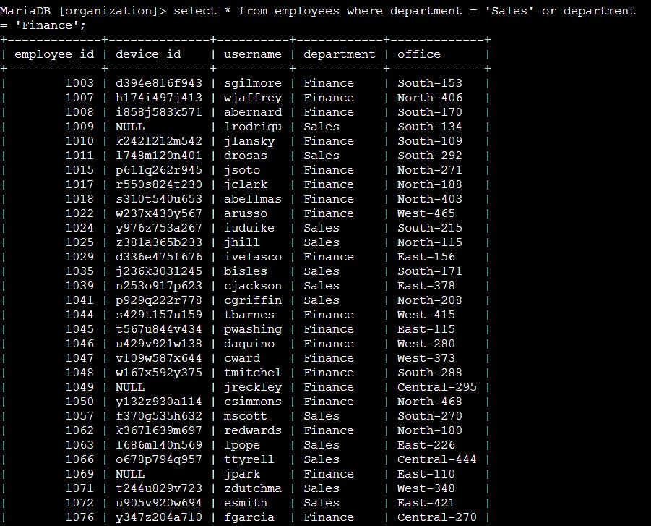

## Retrieve all employees not in IT

The query selects all columns from the ‘employees’ table. The syntax ‘where not’ negates the condition after it, so the query has to show every row apart from the ones where the department column is ‘Information Technology’.

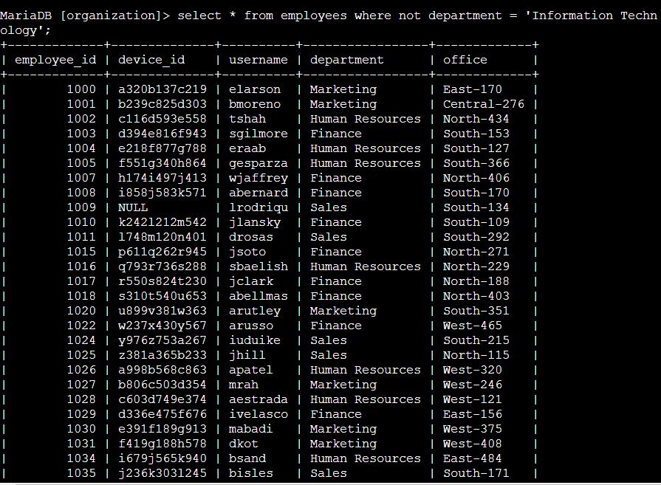

## Summary

In this activity, I retrieved login attempts after working hours and between certain dates, to investigate unusual patterns. Also, I filtered the employees in the Marketing department, working in a specific office, and retrieved all the employees not belonging to the IT department, so that we could update their machines.